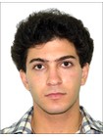Giorgi Chkhaidze

Game Developer and Animator

Profession

Certified Game Developer, successfully video game projects, animations, arts, draws, photoshop. Highly energetic with over 4 years of experience in making videos games for mobile/PC, animations, and storytelling.

Now I making 2D Adventure video game in unity.

**Contacts**

Address: Tbilisi

Phone: 597782547

E-mail:

giorgichkhaidze18@gmail.com

**Work History**

**My Portfolio**: https://www.artstation.com/u6cc8187a

**Public events**

* Developed and promoted corporate brand, images and identity to media and public.
* I have been interested in creating video games since I was 12 years old, I was wondering how popular games would be and at the age of 16 I decided to create my first Georgian video game, I faced a lot of resistance but I released my first game.
* I have made a video games by my self:

**1.** This mobile game I made in 2 weeks: https://drive.google.com/file/d/1- 0V5dzTeDFv6DWUpMCKZ4jX5Qzseuz8s/view?usp=sharing

**2.** This was my first game and I made it in 2 years: https://www.youtube.com/watch? v=2O0LXsiPA64&ab_channel=BLUEEAGLE

**3.** This game i made on 2 days gamejam of Beeline: https://simmer.io/@George18/around-a-fly? fbclid=IwAR3xnPk5FFT4S89cM7JjbWkVfxH9N3GkuqwnP8myUX2CWTNiBYrim37hLL4

**4.** This is my racing game: https://gamejolt.com/games/Furiouslap/503922

**5.** This game was my first 2d platformer game for me: <https://chkhaii.itch.io/crazy-platforms>

Skills

* 5 Stars - Public speaking skills 5 Stars – Adobe Illustrator CC
* 4 Stars - Game prototypes 5 Stars - Blender
* 5 Stars - Gaming design 5 Stars - Adobe Photoshop CC
* 5 Stars - Design development 4 Stars - Unity3D
* 4 Stars - Game Developer 5 Stars - Adobe Premiere Pro
* 5 Stars - 3Ds Max 5 Stars – Adobe Animate
* 4 Stars – AutoCad 5 Stars – TVP Animation 10
* 5 Stars – Adobe XD

Education

**Media Art, Digital Media**

Tbilisi state university of arts – Tbilisi

Hob

I am making games for 4 years and i love making new arts, projects, programs and others...

Language Skills

* Georgian
* English

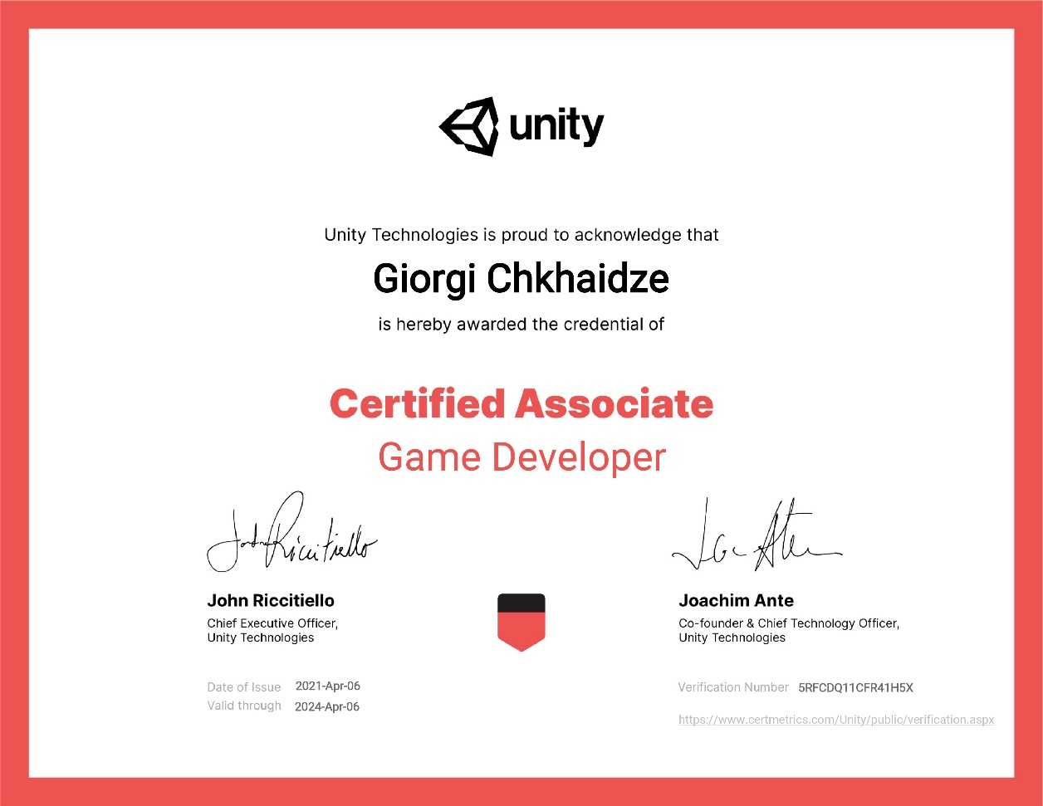

**My Game Developer Certificate**: <https://www.credly.com/badges/f6d6377a-c79a-4ce2-a18e-df3c0b68755f/linked_in?fbclid=IwAR2Zf4vJCsr9yeqw4j3daKpt6donS5WYmPE5fcjUuf3SpPn_oJOrigAvaRM>

